Project Planning Phase
Project Planning Template (Product Backlog, Sprint Planning, Stories, Story points)
Date | 31 July 2026
Team ID | Team 1
Project Name | Employee Software Installation Request through Service Catalog
Maximum Marks | 5 Marks

Product Backlog, Sprint Schedule, and Estimation (4 Marks)
Use the below template to view the product backlog and sprint schedule.
Sprint | Functional Requirement  (Epic) | User Story  Number | User Story / Task | Story  Points | Priority | Team  Members
Sprint-1 | Request Submission | USN-1 | As an employee, I can submit a software installation request via the Service Catalog. | 3 | High | Developer
Sprint-1 |  | USN-2 | As an employee, I will receive a confirmation once my request is submitted. | 1 | High | Developer
Sprint-1 | Approval Routing | USN-3 | As a manager, I can view pending software requests under My Approvals. | 2 | High | Developer
Sprint-1 |  | USN-4 | As a manager, I can approve or reject a request with comments. | 3 | High | Developer
Sprint-1 | Fulfillment | USN-5 | As an IT team member, I receive an auto-created Catalog Task when a request is approved. | 3 | High | Developer
Sprint-2 | Fulfillment | USN-6 | As an IT team member, I can update and close the fulfillment task. | 2 | Medium | Developer
Sprint-2 | Escalation | USN-7 | As the system, I automatically raise an Incident when a request cannot be fulfilled due to license shortage. | 3 | Medium | Developer
Sprint-2 | Notifications | USN-8 | As an employee, I receive an email when my request is approved. | 1 | Medium | Developer
Sprint-2 |  | USN-9 | As an employee, I receive an email when my request is rejected, with the reason. | 1 | Medium | Developer
Sprint-2 | Status Tracking | USN-10 | As an employee, I can view my request status under My Requests. | 2 | Medium | Developer
Sprint-2 | Security | USN-11 | As an admin, I can restrict request visibility using role-based ACLs. | 3 | Low | Developer
Sprint-2 |  | USN-12 | As an admin, I can configure cross-scope access for the application. | 2 | Low | Developer
Sprint-2 |  | USN-13 | As a tester, I can execute UAT scenarios and fix identified issues. | 2 | Low | Developer
Project Tracker, Velocity & Burndown Chart (4 Marks)
Sprint | Total Story  Points | Duration | Sprint Start  Date | Sprint End Date  (Planned) | Story Points  Completed | Sprint Release  Date (Actual)
Sprint-1 | 12 | 6 Days | 03 Feb 2026 | 08 Feb 2026 | 12 | 08 Feb 2026
Sprint-2 | 16 | 6 Days | 10 Feb 2026 | 15 Feb 2026 | 16 | 15 Feb 2026
Velocity:
With a 6-day sprint duration and a total of 28 story points completed across 2 sprints, the team's average velocity (AV) is calculated as:
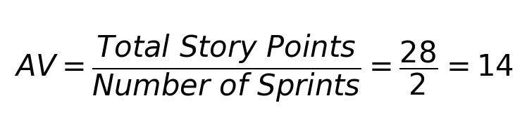
Burndown Chart:
A burndown chart is a graphical representation of work remaining versus time, commonly used in Agile/Scrum to track sprint progress. For this project, actual work completed matched the planned story points in both sprints, indicating the burndown line reached zero on the planned end date each sprint.
Reference:
https://www.atlassian.com/agile/project-management
https://www.atlassian.com/agile/tutorials/epics
https://www.atlassian.com/agile/tutorials/sprints
https://www.atlassian.com/agile/project-management/estimation
https://www.atlassian.com/agile/tutorials/burndown-charts

